

**МІНІСТЕРСТВО ОСВІТИ І НАУКИ УКРАЇНИ**

We are pleased to invite you to take part in the V International Scientific and Practical Internet Conference **«Economic Growth Imperatives in the Context of the Global Sustainable Development Goals»**, which will be held on **April 23, 2024** at the Kyiv National University of Technologies and Design.

The conference will provide information on the status of the ERASMUS+ grant project «International Network of Virtual Youth Business Hubs2 VEHUB4YOU, which is being implemented in 2023-2025 with the participation of Kyiv National University of Technologies and Design.

Scientists, lecturers, subject matter experts, doctoral and postgraduate students of higher education institutions, representatives of the business community of Ukraine and foreign countries, will attend the conference.

**INFORMATION LETTER**

**V International scientific and practical Internet conference**

**«Economic growth imperatives in the context of the Global Sustainable Development Goals»**

**MINISTRY OF EDUCATION AND SCIENCE OF UKRAINE**

**NATIONAL ACADEMY OF PEDAGOGICAL SCIENCES OF UKRAINE**

**KYIV NATIONAL UNIVERSITY OF TECHNOLOGIES AND DESIGN**

**FINANCIAL ACADEMY OF MANAGEMENT**

**MINGACHEVIR STATE UNIVERSITY (REPUBLIC OF AZERBAIJAN)**

**UNIVERSITY OF BUSINESS (WYŻSZA SZKOŁA BIZNESU W DĄBROWIE GÓRNICZEJ) (REPUBLIC OF POLAND)**

**INTERNATIONAL ACADEMY OF APPLIED SCIENCES (ŁOMŻY, REPUBLIC OF POLAND)**

**UNIVERSITY OF FOGGIA (ITALY)**

**GEORGIAN NATIONAL UNIVERSITY SEU (REPUBLIC OF GEORGIA)**

**UNIVERSITY OF APPLIED SCIENCES RISEBA, (REPUBLIC OF LATVIA)**

**INSTITUTE OF TECHNOLOGY AND BUSINESS IN ČESKÉ BUDĚJOVICE (CZECH REPUBLIC)**

**ESTONIAN UNIVERSITY OF APPLIED SCIENCES OF BUSINESS MAINOR (REPUBLIC OF ESTONIA)**

 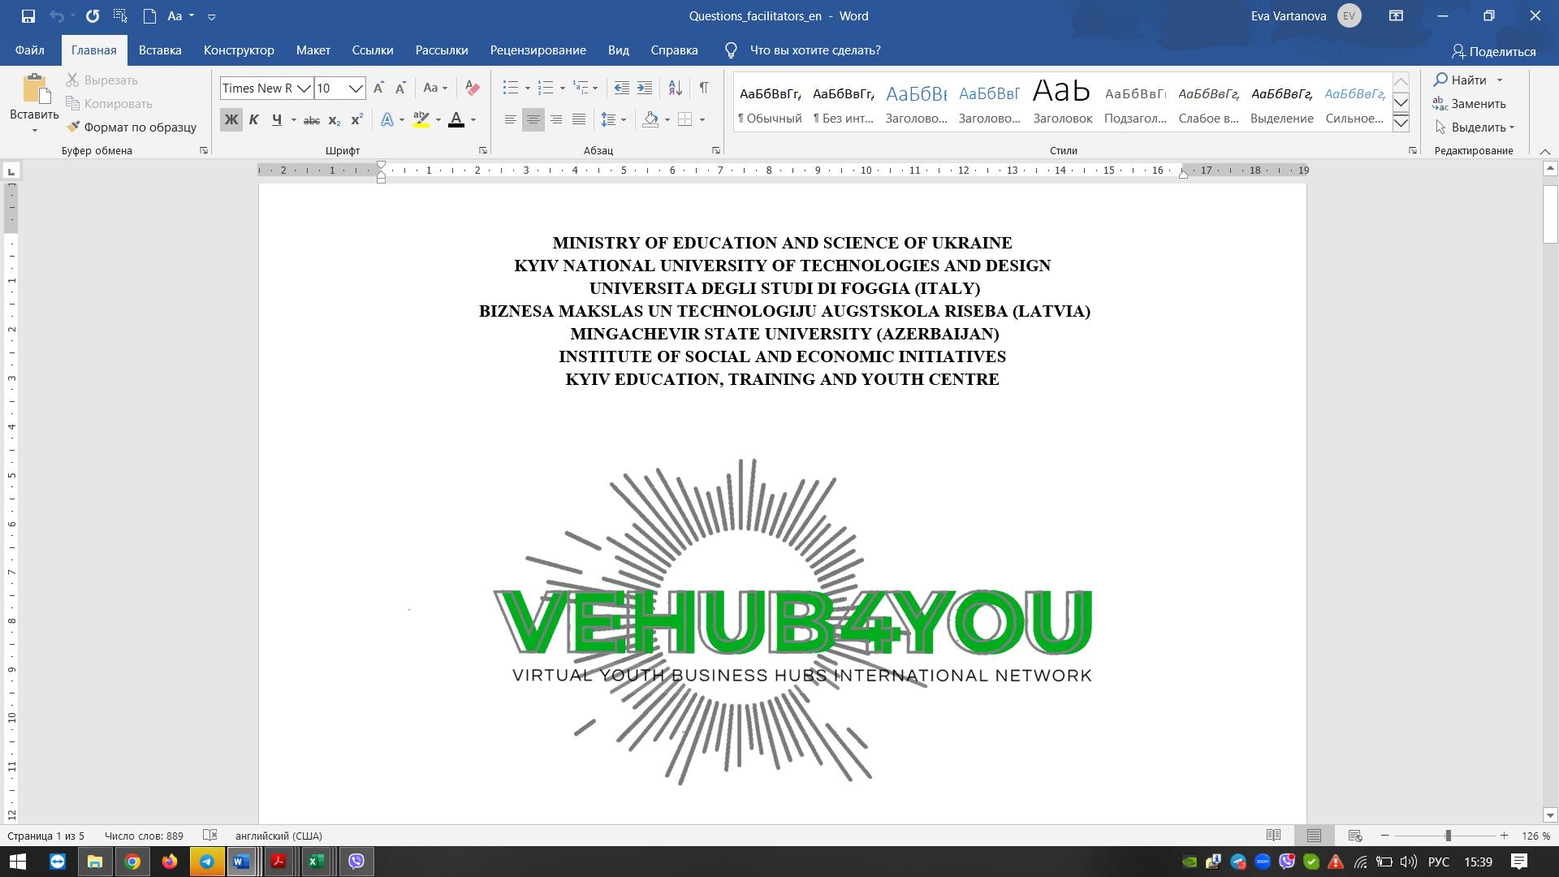

***Within the framework of the grant project***

***ERASMUS-EDU-2021-VIRT-EXCH***

***«International network of virtual***

***youth business hubs» VEHUB4YOU***

**1**

***Platforms of the conference:***

***Platform 1.*** Best European practices of virtual learning in business education and their dissemination in the educational space of Ukraine in the context of the ERASMUS+ VEHUB4YOU project.

***Platform 2.*** SMART specialisation of regions and bioeconomy for sustainable development at the national and international levels.

***Platform 3.*** Entrepreneurial education as a means of achieving sustainable development goals and a tool for the formation of organisational and entrepreneurial capital in Ukraine.

***Platform 4.*** Management 4.0: educational technologies for the digital age.

***Platform 5.*** Financial stability in the digital era: European approaches and peculiarities of their implementation in Ukraine.

***Platform 6.*** Marketing in the context of digital technologies.

**Working languages of the conference:** Ukrainian and English.

***Information about the project’s activities***

***ERASMUS-EDU-2021-VIRT-EXCH***

***«International network of virtual youth business hubs» VEHUB4YOU***

The VEHUB4YOU project focuses on the transfer of business knowledge from the EU to young people in Eastern partner countries through virtual exchange technologies. Thus, on 29 March 2024, the Kyiv National University of Technologies and Design hosted a solemn signing of partnership agreements on cooperation and accession to the International Network of Virtual Youth Business Hubs between its coordinator, the Kyiv National University of Technologies and Design, and the project partners - general secondary, vocational pre-university and higher education institutions of Ukraine. The signing of the agreements was attended by 18 directors of general secondary, vocational pre-university and higher education institutions. Representatives of 22 more educational institutions from Kyiv, Lviv, Kharkiv, Chernihiv, Pereiaslav, Dnipro, Poltava, Boryspil, Kremenchuk, which are joining the Network, participated in the event online. The event was held in the context of the implementation by the Kyiv National University of Technologies and Design of the ERASMUS-EDU-2021-VIRT-EXCH grant project "International Network of Virtual Youth Business Hubs" VEHUB4YOU, which focuses on the transfer of business knowledge from the EU to young people in the Eastern partner countries (13 to 30 years old) through virtual exchange technologies.

As a result of the ERASMUS-EDU-2021-VIRT-EXCH project "International Network of Virtual Youth Business Hubs" VEHUB4YOU, 2500 representatives from 60 hubs and 250 facilitators from the Eastern partner countries, as well as 220 participants from other regions (Southern Neighbourhood and Sub-Saharan Africa) will take part.

The VEHUB4YOU project is expected to improve the quality of business education by providing access to modern European education; at the organisational level of promoting entrepreneurial learning and at the level of individual project participants, it is expected to acquire skills in business planning, product marketing and tools for starting their own business. It is expected to improve the curricula of schools, colleges and universities in line with new trends in virtual learning and increase the effectiveness of virtual education.

**2**

**Requirements for theses**

Top right corner - UDC (Times New Roman, size 14 pt, interval 1.0)

Upper left corner - Surname, initials (bold), academic degree, academic title, place of work, city, country (Times New Roman, font size 14 pt, interval 1.0)

After one blank line, the title of the abstract in large bold in the centre (Times New Roman, size 14 pt, interval 1.5).

After one blank line, the text of the abstract (Times New Roman, font size - 14 pt, interval 1.5).

After the text of the abstracts, the references are given.

The total volume of abstracts is up to 3 full pages in Ukrainian or English.



**Requirements for typing the text**

**Sheet size**: A4 - book size (21 × 29.7 cm).

**Page parameters** (indents from the edge): left - 2.5 cm; right - 1.5 cm; top - 2.0 cm; bottom - 2.0 cm. The font of the abstract is Times New Roman; the stroke is straight; the font size is 14 pt; line spacing is 1.5 (width alignment). Paragraph indentation - 1.25.

*Do not use spaces, tabs, etc. to format the text. Do not set manual word hyphenation or use footers. Place a non-breaking space between the value of a quantity and its unit of measurement (Ctrl + Shift + space).*

**ATTENTION!**

**The theses pages must be filled in completely.**

**Formula set:** MS Equation 3.0 formula editor. **Do not use** graphical objects, frames, or tables for a formula set. **A table** header (14 pins) is required.

Table 1

Dynamics of changes

|  |  |  |  |
| --- | --- | --- | --- |
| Spacing |  | 1 | 1 |
| Thesis font |  | 12 | 12 |

**Figures** must be accompanied by centred sub-figure captions (size 14) (example in Fig. 1).

Fig. 1. Design schools in leading universities in Kyiv [source].

Colored and background figures are not allowed.

The list of references is highlighted with the subtitle "Literature" (Times New Roman, font size - 14 pt; bold, centre) and is drawn up according to the requirements of DSTU 8302:2015 "Information and Documentation. Bibliographic reference. General requirements and rules of compilation", should be given at the end of the abstract. Each item in the list should be referenced in the text in square brackets. Footnotes at the bottom of the page are not allowed.

**We draw the authors' attention to the fact that it is forbidden to cite in the text and include in the bibliographic lists those sources that are published in Russian in any country.**

*The Organising Committee reserves the right not to include abstracts that do not comply with the requirements.*

**The author is solely responsible for the accuracy of the information provided!**

**3**

**Conditions of participation in the conference**

**Participation in the conference is FREE !!!**

Applications for participation in the conference (full name, academic degree, place of work, position, contact phone number, e-mail) and abstracts in electronic version should be sent to the organising committee at **conf_knutd_2024@ukr.net** **by April 19, 2024.**

Upon receipt of the materials, the organising committee must send a notification confirming the fact of their acceptance for publication. The conference proceedings will be published in .pdf format.

**Organizing committee address:** 01011, Kyiv, Nemirovich-Danchenko str., 2, building 4, Kyiv National University of Technologies and Design

**Responsible secretary:** Doctor of Economics, Associate Professor, Assoc. Prof. of the Department of Smart Economics Polina PUZYROVA

mobile: +38(067) 598-55-73

e-mail: [**conf_knutd_2024@ukr.net**](mailto:conf_knutd_2024@ukr.net)

**Application for participation**

**in the V International Scientific and Practical Internet Conference**

**«Economic Growth Imperatives in the Context of the Global Sustainable Development Goals» April 23, 2024**

**Kyiv KNUTD**

|  |  |
| --- | --- |
| Surname |  |
| First name |  |
| Patronymic |  |
| Academic degree, academic title |  |
| Scientific interests |  |
| Do you plan to participate in full-time/extra-mural participation (please fill in) |  |
| Place of work |  |
| Position |  |
| Work address |  |
| Phone (with area code) and (or) mobile phone |  |
| E-mail |  |
| Name of the platform |  |
| Title of the report |  |

**4**

**Sample of thesis formatting**

UDC 330

**Puzyrova P.,**

Doctor of Economics, Associate Professor,

Kyiv National University of Technologies and Design,

Kyiv, Ukraine

**FINANCIAL STABILISATION AS A MECHANISM OF POST-WAR RECOVERY**

Text, text, text, text, text, text, text, text, text, text, text, text, text, text, text, text, text, text, text, text, text, text, text, text, text, text, text, text, text, text, text, text, text, text, text, text, text, text, text, text, text,…..

**References**

1. Vynohradnia, V. M., Burdonos, L. I. (2021). Perspektyvna platospromozhnist u zabezpechenni finansovoi stabilnosti pidpryiemstva [Perspective solvency in ensuring the financial stability of the enterprise]. *Ekonomichnyi visnyk universytetu = Economic Bulletin of the University*, Issue 50, РР. 162-168 [in Ukrainian].
2. Melnyk, L. M., Kondratska, N. M., Duma, V. L. (2022). Rol biudzhetnoi bezpeky u zabezpechenni stabilnosti finansovoi systemy Ukrainy [The role of budget security in ensuring the stability of the financial system of Ukraine]. *Visnyk Natsionalnoho universytetu vodnoho hospodarstva ta pryrodokorystuvannia. Ekonomichni nauky = Bulletin of the National University of Water and Environmental Engineering. Economic Sciences*, Issue 4. РP. 90-100 [in Ukrainian].

**5**