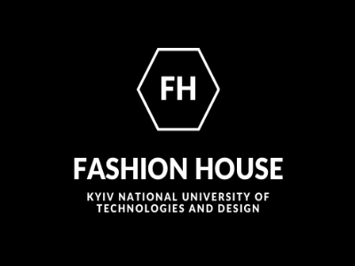

XІХ International Competition of one image and New Year's – Christmas decor
" SUZIRYA KASHTAN "- 2021

December 21, 2021 - Kyiv National University of Technology and Design
(remotely)

The Organizing Committee of the competition announces the beginning of the preparatory stage of the XIX International Competition of one image and New Year - Christmas decor " Suzirya kashtan" and invites you to participate in the competition program.

The Competition is open to students and young designers and fashion designers who are educated in the fields of design, fashion industry, textile industry.
The competition consists of three professional sub-competitions: clothing; shoes and accessories; New Year and Christmas decor.
The competition is held in two stages:
the first - selection (participants send their videos with images, according to which the jury decides on the passage to the next stage);
the second - the final, determination of winners and awards.
Participation in the competition program becomes possible by submitting an application for participation and video material.
The number of participants from one educational institution is unlimited.
Each contestant has the right to participate in any nomination (including several at the same time, but with different entries). Mandatory condition: the works are author's, original.
Materials submitted for participation in the competition must be submitted within the deadlines set by the organizing committee (which are specified in the invitations to participate).
The competition is held in nominations:
ONE EXAMPLE
YULE | traditions of national festivities and national costumes: heroes of the scene, fairs, festive, festive | One image
NEW YEAR'S BALL | evening or haute couture ensembles | One image
MASQUERADE | spectacular, figurative masquerade costume, made with the use of traditional and non-traditional materials and their processing: fairy-tale, literary, historical characters | One image
SHOE MONPASSIUM | One pair of festive shoes, possibly in combination with accessories | One image
NEW YEAR - CHRISTMAS DECOR

CHRISTMAS VERTEP | from different materials: straw, cardboard, gypsum, etc., at least 50 * 50 cm | One product
CHRISTMAS TREE TOY | toys from traditional (glass, plastic, textiles) and any non-traditional materials | From one to three products in the collection
CHRISTMAS TREE | The Christmas tree is made of any materials | One product
NEW YEAR POSTCARD | Postcards are made of traditional and any non-traditional materials | From one to three products in the collection
PANEL | The panel is made using textiles and any other materials | One product
TEXTILE PRODUCTS | New Year, Christmas products made using textiles | One product
CHRISTMAS JEWELRY | Sketches of a set of jewelry for the New Year - Christmas theme with the use of precious metals and stones. | One sketch of the kit
 | The sketch of jewelry of New Year's - Christmas subjects with use of precious metals and stones is developed in the program of 2-D or 3-D graphics. | One layout

Awards: 1, 2, 3 place for each of nominations. By the decision of the jury, the number of prize places in each nomination may vary.
Prizes: Free participation in the International Competition of Young Designers "Pechersk Chestnut" 2022, award diplomas and souvenirs.

COMPETITION MATERIALS AND DEADLINES FOR SUBMISSION TO THE ORGANIZING COMMITTEE

- November 5 to December 15, 2021 the participants of the competition program must fill in the and send sketches of their works
https://cutt.ly/rg7wMQL

2. 17.12.2021 – 20.12.2021 – summarizing according to the jury.
3. 21.12.2021 – final, awarding the winners.

Participation in the contest - 150 UAH. (Payment terms will be reported by the organizers in addition).
For students of KNUTD - for free

Competition director: Olena Shevchuk - +380934240518; +380688664502
https://www.facebook.com/pecherskiek
https://www.facebook.com/profile.php?id=100011408429062

